Project for the Bachelor of Information and Technology
Doctor’s Appointment System



Submitted By:
Anish Thapa (310878)
Prasan Poudel (310900)
Raj Khadka (310905)

KIST College of Information Technology(KIST)
Faculty of Science and Technology
Purbanchal University, Nepal
2nd August,2024

Acknowledgement

We take this opportunity to express our profound appreciation and regards to the Information Technology (IT) department for this commendable guidance, monitoring and constant encouragement throughout the course of this project. The help and guidance given by shall carry us a long way, in the journey on which we are about to embark.

We also take this opportunity to express a deep sense of gratefulness to our coordinator Mr. Deepak Khadka for his amiable support, valuable information and guidance, which helped us in completing this task throughout its various stages by giving us his precious time. We are also indebted to all members of KIST College, for the valuable suggestions and help provided by then in their respective fields. We are grateful for their cooperation during the period of our project.

Finally, we would also like to express lots of thanks to PURBANCHAL UNIVERSITY for designing such a wonderful course structure. It will help us to get more knowledge in the field of Information Technology & help us to have a bright future in the field of technology. We hope our University will accept this attempt as a successful project.

Examiner’s Certification

This is to certify that the project entitled “Doctor’s Appointment System” has been successfully completed by Mr. Anish Thapa, Mr. Prasan Poudel, and Mr. Raj Khadka in partial fulfillment of Degree of Bachelor of Information Technology of Purbanchal University during the academic year 2024 under the guidance of our coordinator and subject teacher Mr. Deepak Khadka.

__________________________________

Department of Science and Technology
PURBANCHAL UNIVERSITY

Student Declaration

Our project titled “Doctor’s Appointment System” is a consequence of our own work and indebtedness to other work publication and references have been wholly acknowledged. If we have been found guilty of copying any other report or information and showing as our original work, we shall be punishable by University, which may include failing in examination or any other punishment that Purbanchal University decide, which we understand very nicely so, it is a pure effort of our own.

We further certify that this project is submitted in fulfillment of requirement for the project marks of Bachelor in Information Technology(BIT) 1st Semester. So, it is our original work and has not been submitted for award of any other degree or title.

S.N | NAME | Reg. No. | Symbol No. | Signature
1. | Anish Thapa | 058-3-2-02412-2023 | 310878
2. | Prasan Poudel | 058-3-2-02440-2023 | 310900
3. | Raj Khadka | 058-3-2-02437-2023 | 310905

CERTIFICATE

This project entitled “Doctor’s Appointment System” prepared and submitted by Anish Thapa, Prasan Poudel and Raj Khadka has been examined by us and is accepted by the degree of Bachelor’s of Information Technology by Purbanchal University.

Manoj Kumar Haluwai Signature Date: 2nd August,2024
Assoc. Prof.

Deepak Khadka Signature Date: 2nd August,2024
Supervisor

Deepak Khadka Signature Date: 2nd August,2024
Coordinator of BIT

ABSTRACT

The "Doctor's Appointment Management System" project aims to streamline and enhance the efficiency of scheduling appointments between patients and healthcare providers. This system addresses the challenges of manual appointment booking, including double bookings, long waiting times, and the inefficiencies associated with paper-based records.
The project involves the design and implementation of a web-based application that allows patients to book, cancel, and reschedule appointments with doctors. Key features include user authentication, real-time availability checking, automated reminders, and a user-friendly interface. The system also provides doctors with a comprehensive dashboard to manage their schedules, view patient histories, and communicate directly with patients.
Developed using [mention key technologies, e.g., C progamming language , the system ensures data security and privacy and secure login procedures. The implementation of this system is expected to significantly reduce administrative burdens on healthcare staff, minimize appointment-related errors, and improve overall patient satisfaction by providing a seamless and efficient appointment booking experience.
The project demonstrates the effective application of web development skills and highlights the potential for technology to solve practical problems in the healthcare sector.

Table of Content

CHAPTER 1: INTRODUCTION 5
1.1 INTRODUCTION 5
1.2 PROBLEM STATEMENTS 5
1.3 OBJECTIVES 6
1.4 PATIENT VIEW 6
1.5 FUTURE OF THE PROJECT 6
1.6 ADMIN VIEW 6
CHAPTER 2: ACKNOWLEDGEMENT 7

CHAPTER 3: PROPOSED SYSTEM 8

CHAPTER 4: FUNCTION MODULE 9

CHAPTER 5: CONSOLE DESIGN: 10

CHAPTER 6: ALGORITHM 12
1. LOGIN PAGE(MAIN PAGE): 13
2. SIGN UP 13
3. FORGET PASSWORD 14
4. ADMIN LOGIN 14

CHAPTER7:FLOWCHART ....................................................................................................16

CHAPTER 8: CONCLUSION 20

CHAPTER 9: REFERENCE 21
1. PASSWORD MASK AND PRINTING “*”. 21
2. GUIDANCE FROM: 21

Chapter 1: Introduction

1.1 INTRODUCTION

In these modern era, health is one of the essential factor that effect the human life. Healthcare service includes various items which helps the patient to get the proper service and good result. Effective management of appointment system of doctor also plays the vital role to provide proper service to the patient. So, understanding the requirement of the market we developed the system called DOCTOR’S APPOINTMENT SYSTEM.
This documentation presents a comprehensive guide to the project which is developed by using C programming.

1.2 PROBLEM STATEMENTS

Traditional method of appointment system contains lot of issues like long waiting time, scheduling error and many more. It creates the problem to the patient whose condition is not good. It may also create the misunderstanding or conflict which hamper the image of the institution. So, the implementation of these system provides various benefits as well as help the health provider to run the system smoothly.

1.3 OBJECTIVES

Our system have only objective to provide effective and transparent way of booking an appointment for patient. It also provide privacy and security to patient information.

1.4 PATIENT VIEW
- It contains the useful features like login and forget password.
- It provides the security or privacy to the patient information.
- It provides the information of the doctor like (qualification, specialty etc.) which helps the patient to book the appointment easily.

1.5 FUTURE OF THE PROJECT

In future we can add few things to improve our project:
- Color can be added in the console or output to increase the readability and comfort of user.
- Users data can be handled more securely using encryption and decryption.
- This system can be launched in world wide web (WWW) to have live version on internet.
- SMS Alert direct to phone.

1.6 ADMIN VIEW

- It contains login feature.
- Admin are asked to enter their username and password.
- It helps to organize and list all the appointments made by patients.

Chapter 2: Acknowledgement

We take this opportunity to express our profound appreciation and regards to the Information Technology (IT) department for this commendable guidance, monitoring and constant encouragement throughout the course of this project. The help and guidance given by shall carry us a long way, in the journey on which we are about to embark.

We also take this opportunity to express a deep sense of gratefulness to our coordinator Mr. Deepak Khadka for his amiable support,valuable information and guidance, which helped us in completing this task throughout its various stages by giving us his precious time. We are also indebted to all members of KIST College, for the valuable suggestions and help provided by then in their respective fields. We are grateful for their cooperation during the period of our project.

Finally, we would also like to express lots of thanks to PURBANCHAL UNIVERSITY for designing such a wonderful course structure. It will help us to get more knowledge in the field of Information Technology & help us to have a bright future in the field of technology. We hope our University will accept this attempt as a successful project.

Chapter 3: Proposed system

With the use of our system, any patients won’t face any problem while booking online appointment with any doctor. The user will get decent experience and will have ease in booking appointments. Our Doctor’s Appointment System has been designed with a user-friendly interface that ensures a smooth and stress free experience for patients. The simplicity of the platform allows user to quickly pass or go through the booking process without unnecessary complications or confusions. Our system is very simple and clear in all aspects, making it easy for user. The booking process is straightforward and important information such as doctor’s timing and speciality are presented in a clear and concise manner.

The core of our system is a C program that ensures efficient and reliable performance. C is a group of building blocks called function which is sub routine that may include one or more statement designed to perform a specific task. C is known for its low level system control, speed and minimal resource consumption making it an excellent choice for building a high performance doctor’s appointment system. This results in faster response times and smoother experience.

To sum up, our Doctor’s Appointment System stands out for its simplicity, ease of use, effective response time and straightforward user experience. Its simplicity, clear communication and commitment to accessibility make it a user friendly choice.

Chapter 4: Function Module

The programming language used in developing this system is C programming language, which ensures efficient and reliable performance with minimal resource consumption. User can get hassle free experience while using this appointment system. Module of this program is in this way:

Function Module | Description
Doctor’s Information -> | This allows you to see doctor’s speciality and name of doctor.
Patient Details -> | User have to enter their details for the appointment with doctor.
Timing and Confirmation -> | Provides you timing of doctor and asks confirmation with user to continue.
User Login -> | Login feature asks user aboutt their username and password for booking, which makes system more secure and privacy is maintained.
Admin Login -> | Helps admin to organize all the appointments made by patients.

Chapter 5: Console Design:

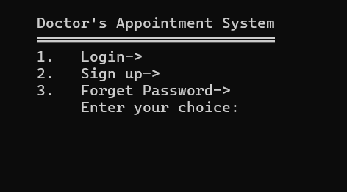

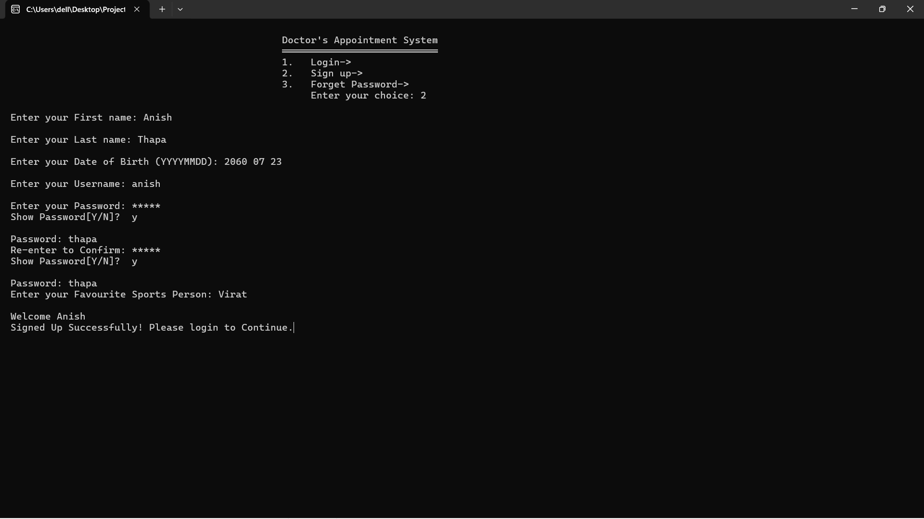
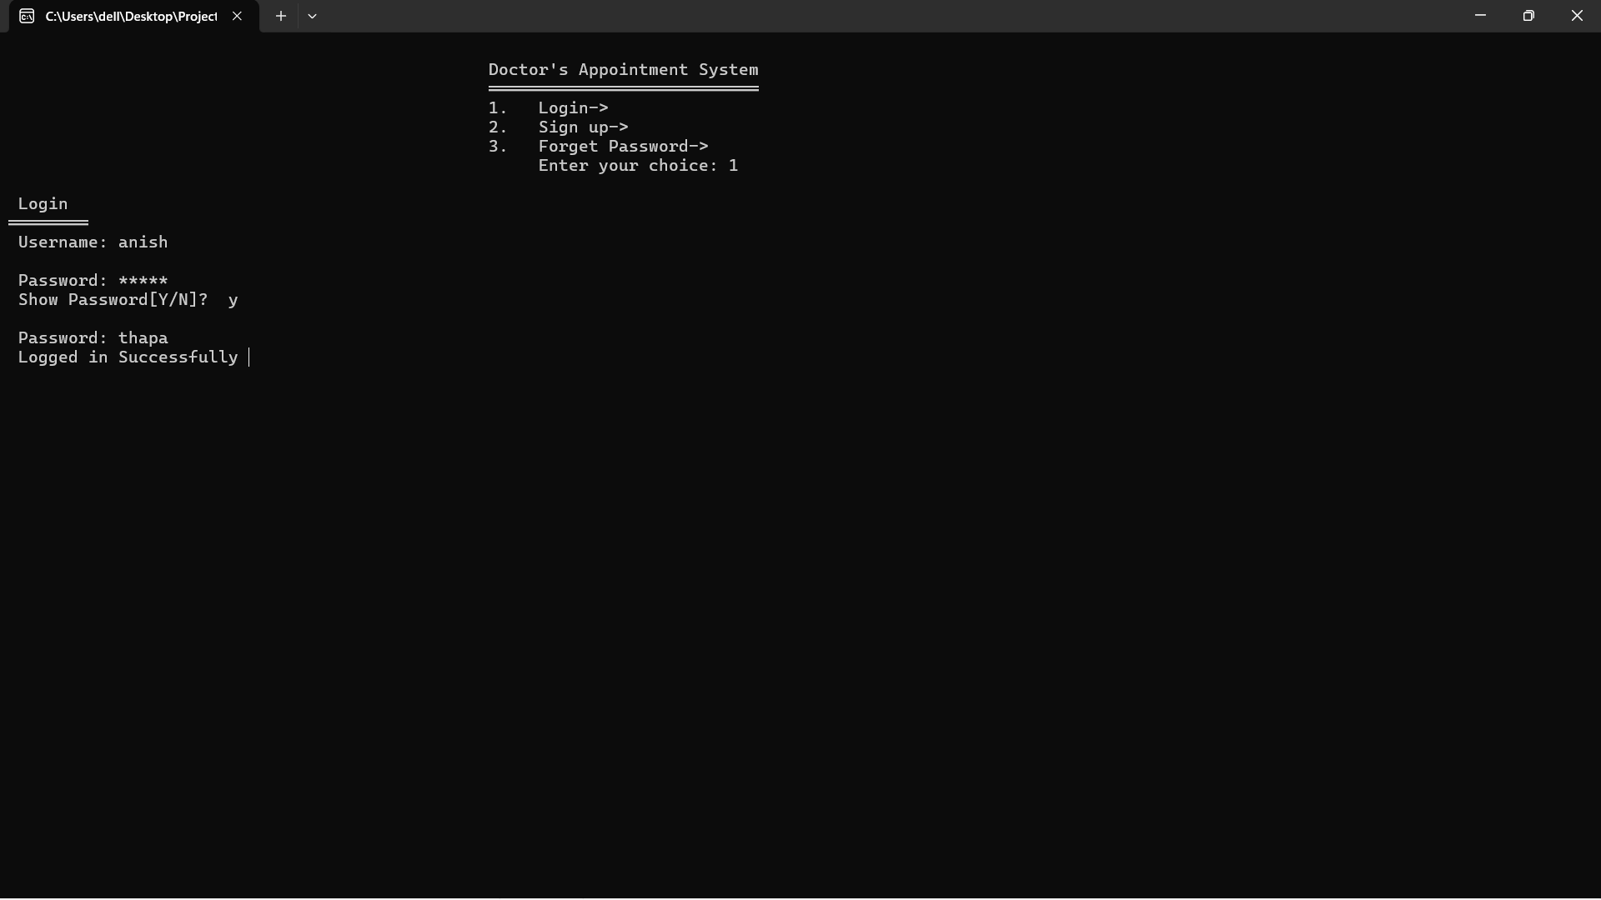

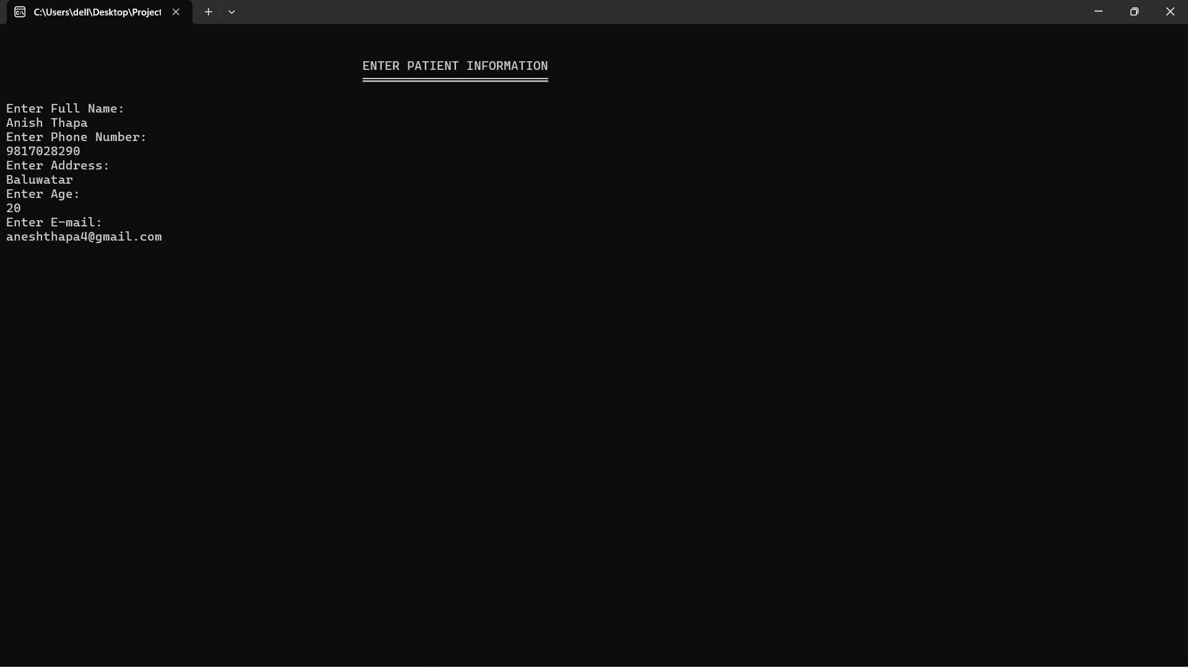

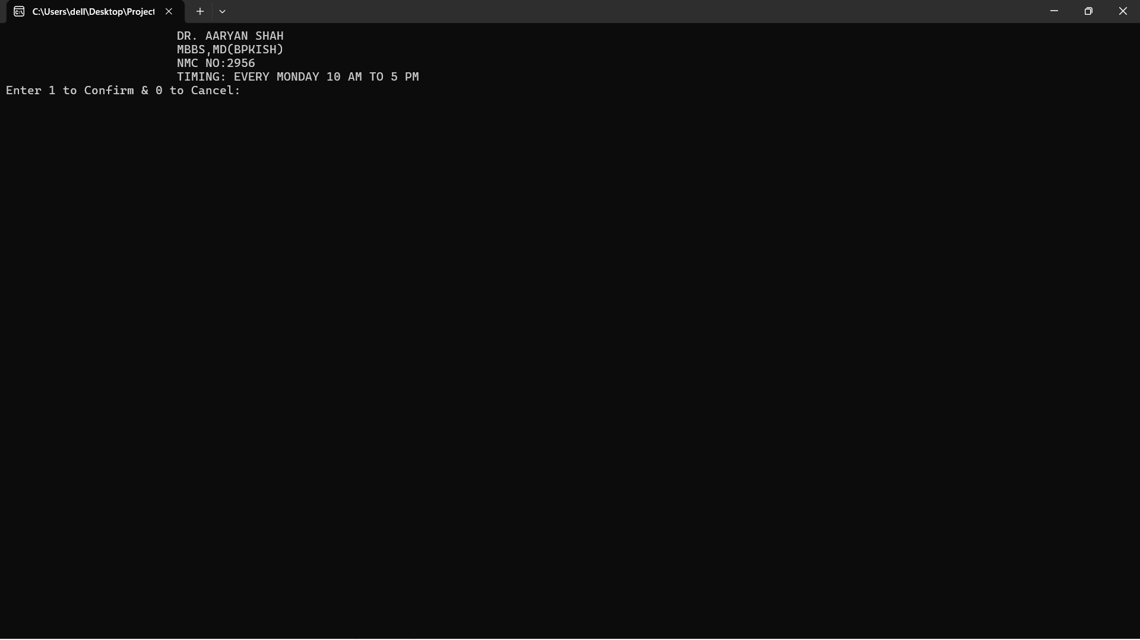

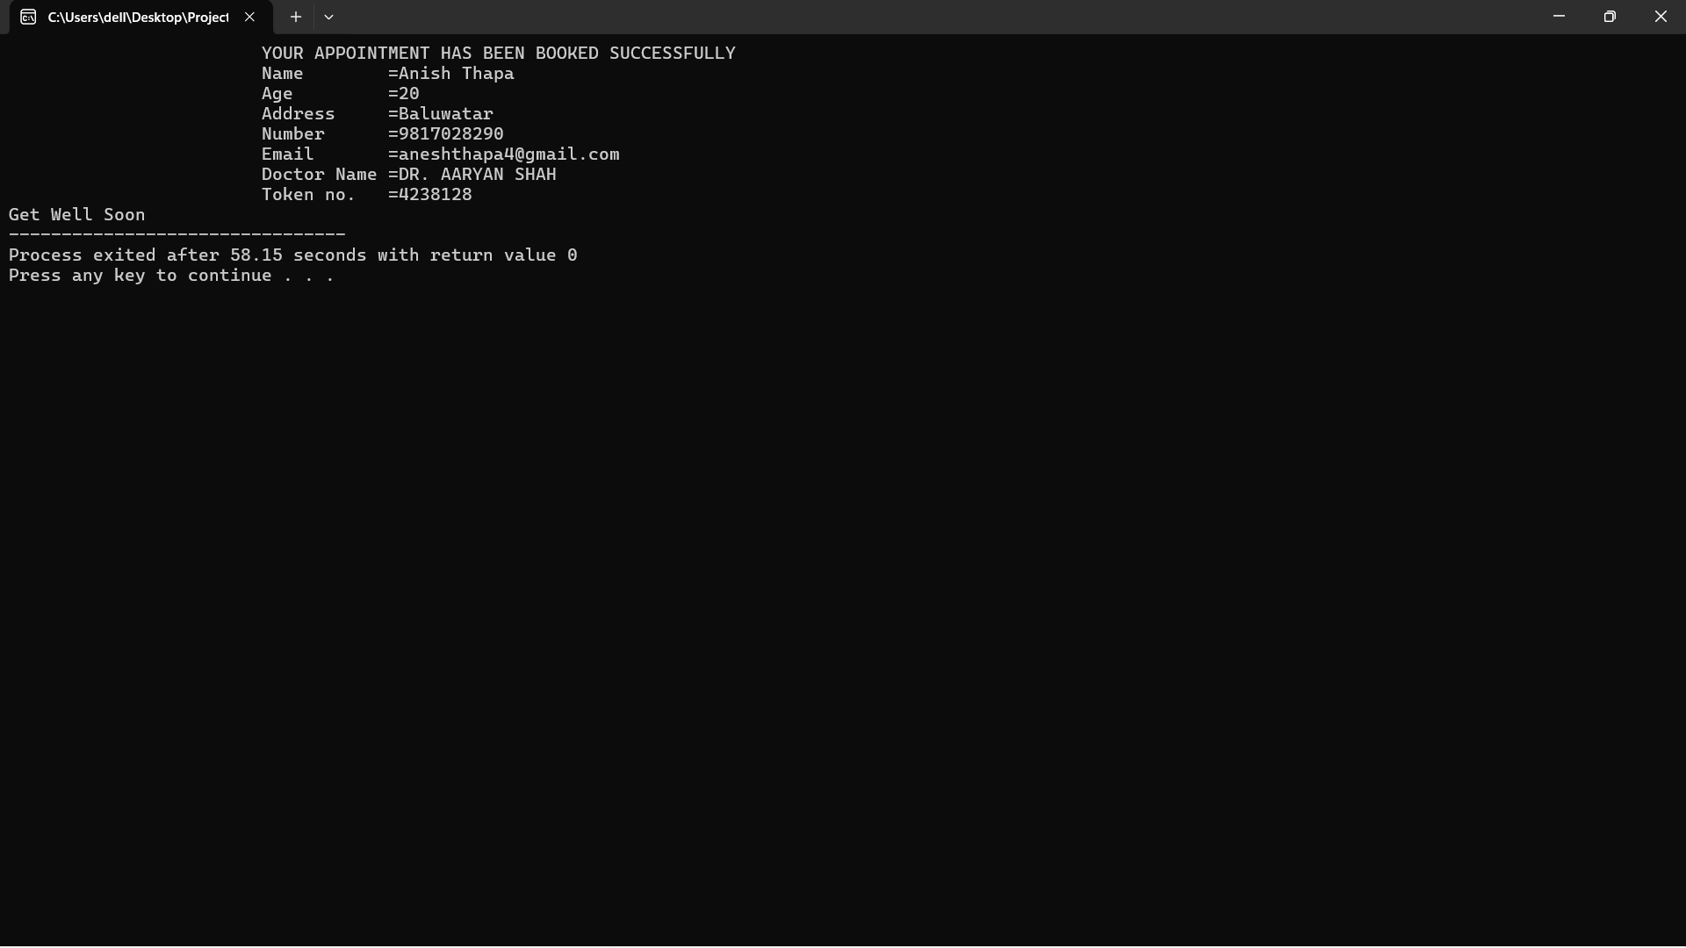
Chapter 6: Algorithm
Step 1: START.
Step 2: Include necessary libraries.
Step 3: Define structures for sign and patient.
Step 4: Declare variables and initialize file pointer.
Step 5: Open file data.txt and itti.txt. If the file cannot be opened, print an error
message and exit.
Step 6: Display the main menu with Login, Sign up and Forget password options.
- Login Page(Main Page):
Step 7: Check choice of user either its user login or admin login.
Step 8: Input username and password.
Step 9: Check if the entered username and password exists in file or not.
Step 10: Display entered password as “*”.
Step 11: Check if the inputted username and password matches from file or not, if not then display “incorrect username or password” and ask to re-enter, if yes display “Login successful”.
Step 12: After login show details of doctor’s with their speciality and ask user to enter their choice of doctor. If the choice is valid, ask the user to enter patient information.
Step 13: According to choice open switch case.
Step 14: Ask to enter patient information, that consist of ->
- Patient’s Full Name.
- Phone Number.
- Address.
- E-mail.
Step 15: Show their doctor’s details with timing of appointment and availability.
Step 16: Ask user to confirm or cancel their appointment.(If 1 confirm their appointment and display their details, if 0 then cancel their request and exit.)
Step 17: For every cases (1 to 11), display specific doctor details. Also ask for the confirmation to book the appointment.
Step 18: If confirmed, save the patient information and display a success message.

- Sign Up
Step 19: Open file.
Step 20: Display to enter user’s information ->
- First Name.
- Last Name.
- Date of Birth.
- Username and Password.
- Re-enter Password.
- Mask Password with “*”.
- Favourite Sports Person (For security reasons.)
Step 21: Display “Signed Up Successfully! Please login to Continue”
Step 22: Jump to Main Menu for login.

- Forget Password
Step 23: Ask user to enter their favourite sports person and date of birth.
Step 24: Check their given details from file.
Step 25: If it matches ask them to reset their new password, if not jump into same security question.
Step 26: After password reset display “Password Updated Successfully! Login to Continue”.

- Admin Login

Step 27: Function named listPatient is added above int main.

Step 28: Function is called in admin login case.
Step 29: Asks admin for username and password.
Step 30: Username and password for admin are always same.
Step 31: After login show loading message with delay.
Step 32: List all the appointments made by patients.
Step 33: Close all opened files and cases.
Step 34: Print a “Get Well Soon” message.
Step 35: END/STOP.
Chapter7:Flowchart: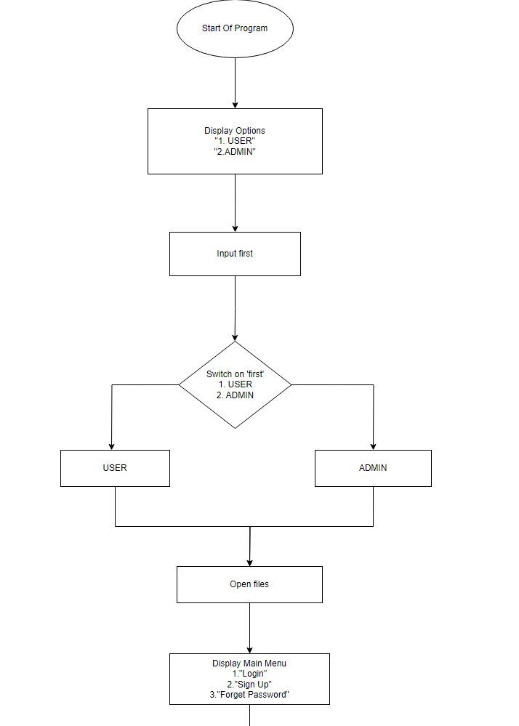

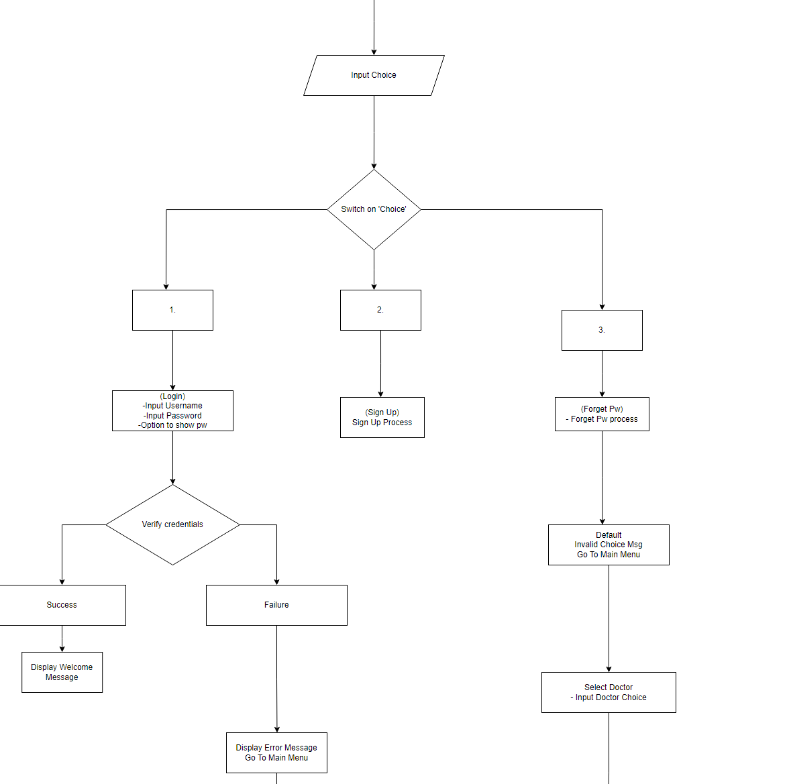
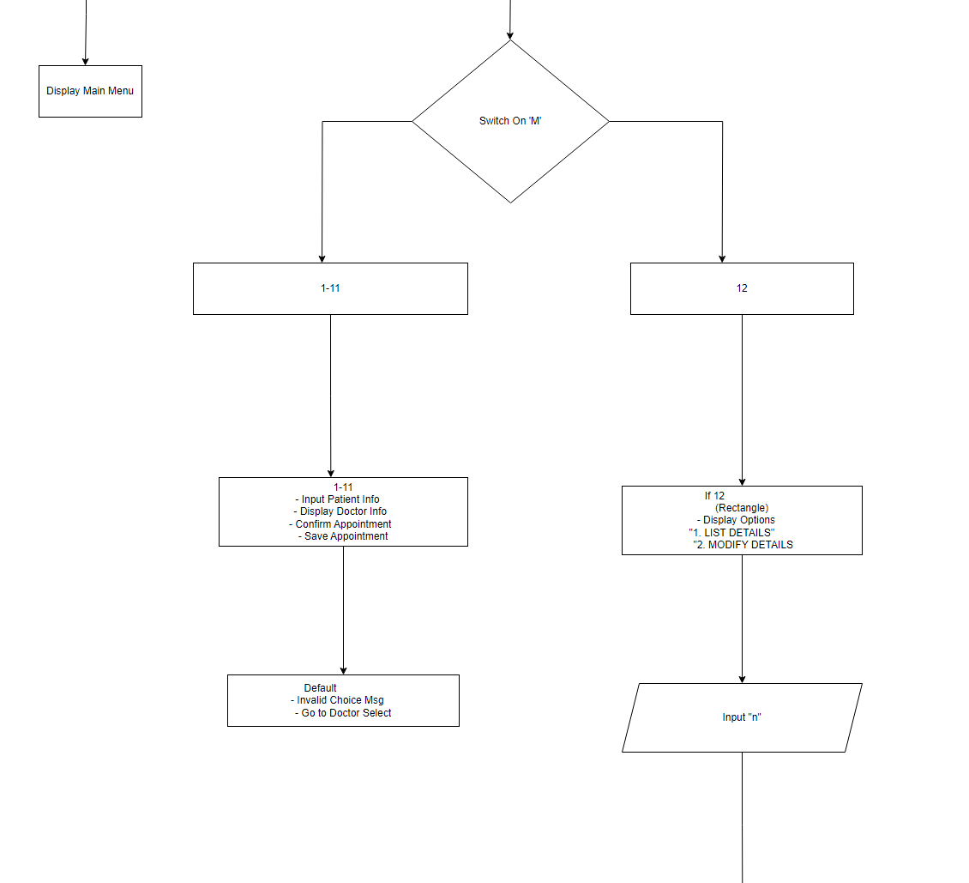

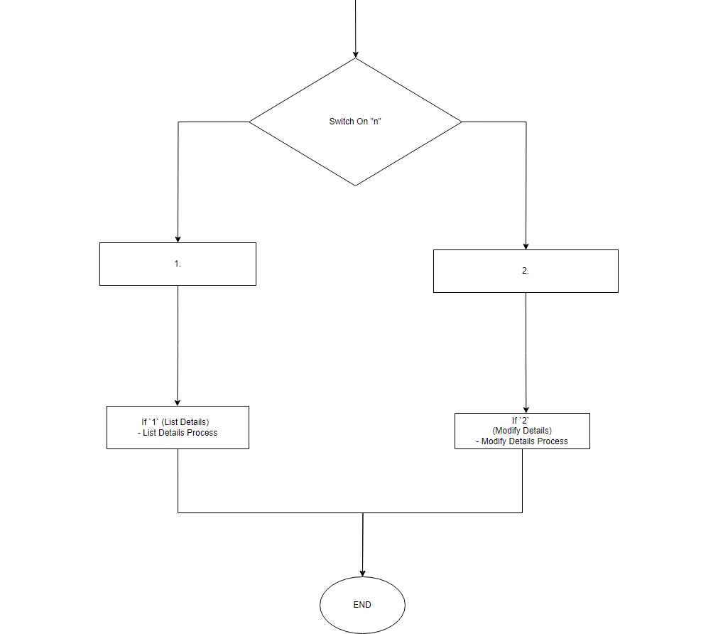

Chapter 8: Conclusion

In conclusion, the project for the doctor’s appointment system developed using C presents an innovation solution to streamline and enhance the booking process for medical appointment system. By leveraging the power of C programming language, we aim to create user-friendly and efficient platform that enables users to easily book and manage their time wasted in queue just for the appointment.

Through our proposed system, we intend to address the challenges faced by users in traditional booking methods, such as time-consuming processes, limited availability, and lack of transparency. By automating the booking process and integrating real-time data, our solution will provide users with a seamless and hassle-free experience.

To sum up, we are confident that our solution will significantly improve efficiency, convenience, and customer satisfaction in the industry.

Chapter 9: Reference

To develop this system certain helps are taken from different websites and also from our coordinator also our project teacher.
- Password mask and printing “*”.
http://www.stackoverflow.com
- Guidance from:
Deepak Khadka.
9851184846.
BIT Coordinator, Kist College of Information and Technology.

